Storage Manager

💾 What Is a Storage Manager in a DBMS?
# Source: AI Source: Provided by: [Data Path: Persons Table -> ID Column: 1, Name_En Column: Motasem Essam] -> From: [ChatGPT] on [6/10/2026]
The Storage Manager is the component of a Database Management System (DBMS) responsible for handling how data is physically stored, retrieved, and managed on disk (or memory).
It's like the warehouse manager of the database — it knows where everything is and how to get it efficiently when requested by the database engine.

🧱 Key Responsibilities of the Storage Manager
# Source: AI Source: Provided by: [Data Path: Persons Table -> ID Column: 1, Name_En Column: Motasem Essam] -> From: [ChatGPT] on [6/10/2026]
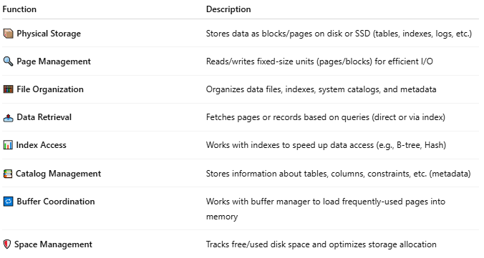
Function | Description
📦 Physical Storage | Stores data as blocks/pages on disk or SSD (tables, indexes, logs, etc.)
🔍 Page Management | Reads/writes fixed-size units (pages/blocks) for efficient I/O
🧮 File Organization | Organizes data files, indexes, system catalogs, and metadata
📤 Data Retrieval | Fetches pages or records based on queries (direct or via index)
📊 Index Access | Works with indexes to speed up data access (e.g., B-tree, Hash)
📚 Catalog Management | Stores information about tables, columns, constraints, etc. (metadata)
🔁 Buffer Coordination | Works with buffer manager to load frequently-used pages into memory
🛡️ Space Management | Tracks free/used disk space and optimizes storage allocation

🧠 How It Fits in the DBMS Architecture
# Source: AI Source: Provided by: [Data Path: Persons Table -> ID Column: 1, Name_En Column: Motasem Essam] -> From: [ChatGPT] on [6/10/2026]
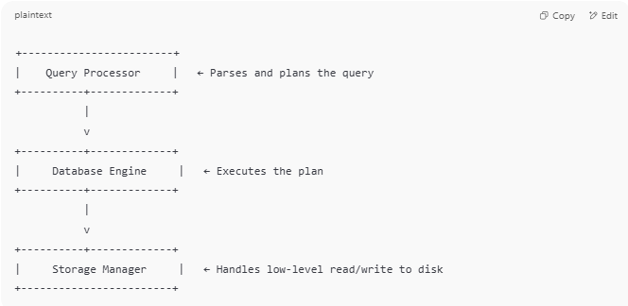
+------------------------+
| Query Processor | ← Parses and plans the query
+----------+-------------+
|
v
+----------+-------------+
| Database Engine | ← Executes the plan
+----------+-------------+
|
v
+----------+-------------+
| Storage Manager | ← Handles low-level read/write to disk
+------------------------+

🗃️ Real Components Inside a Storage Manager
# Source: AI Source: Provided by: [Data Path: Persons Table -> ID Column: 1, Name_En Column: Motasem Essam] -> From: [ChatGPT] on [6/10/2026]
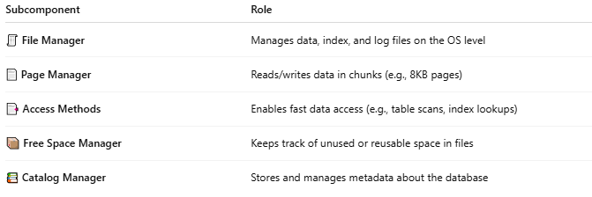
Subcomponent | Role
🧾 File Manager | Manages data, index, and log files on the OS level
📄 Page Manager | Reads/writes data in chunks (e.g., 8KB pages)
📑 Access Methods | Enables fast data access (e.g., table scans, index lookups)
📦 Free Space Manager | Keeps track of unused or reusable space in files
📚 Catalog Manager | Stores and manages metadata about the database

🧪 Example (Simplified)
# Source: AI Source: Provided by: [Data Path: Persons Table -> ID Column: 1, Name_En Column: Motasem Essam] -> From: [ChatGPT] on [6/10/2026]
You run:
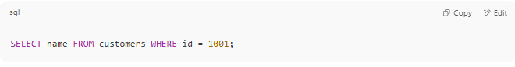
SELECT name FROM customers WHERE id = 1001;

- Query processor creates an execution plan.
- Storage manager checks:
  - "Where is the customers table stored?"
  - "Is there an index on id?"
  - "What pages need to be read?"
- It fetches those pages from disk or memory.
- The engine gets the data and sends results back.

⚖️ Summary Table
# Source: AI Source: Provided by: [Data Path: Persons Table -> ID Column: 1, Name_En Column: Motasem Essam] -> From: [ChatGPT] on [6/10/2026]
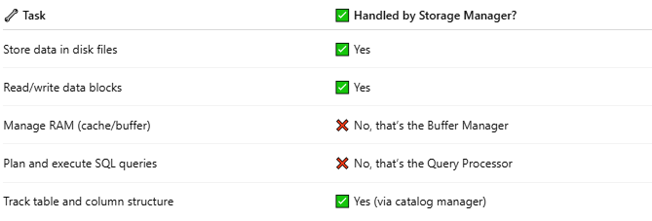
🔧 Task | ✅ Handled by Storage Manager?
Store data in disk files | ✅ Yes
Read/write data blocks | ✅ Yes
Manage RAM (cache/buffer) | ❌ No, that’s the Buffer Manager
Plan and execute SQL queries | ❌ No, that’s the Query Processor
Track table and column structure | ✅ Yes (via catalog manager)

📌 Summary
# Source: AI Source: Provided by: [Data Path: Persons Table -> ID Column: 1, Name_En Column: Motasem Essam] -> From: [ChatGPT] on [6/10/2026]
The Storage Manager is the part of the DBMS that knows where and how to store and retrieve the actual data from disk. It's essential for efficient, reliable, and organized storage.

